**DAILY ONLINE ACTIVITIES SUMMARY**

|  |  |  |  |  |  |  |  |  |
| --- | --- | --- | --- | --- | --- | --- | --- | --- |
| **Date:** | **31/05/2020** | | | | | **Name:** | **Varsha H Shetty** | |
| **Sem & Sec** | **8th B** | | | | | **USN:** | **4AL16CS117** | |
| **Online Test Summary** | | | | | | | | |
| **Subject** | | **IOT** | | | | | | |
| **Max. Marks** | | **20** | | **Score** | | | **19** | |
| **Certification Course Summary** | | | | | | | | |
| **Course** | **Introduction to Amazon CloudFront** | | | | | | | |
| **Certificate Provider** | | | **Great learning** | | **Duration** | | | **10 minutes** |
| **Coding Challenges** | | | | | | | | |
| **Problem Statement:**  **prob1:-write a c program to sort an array of integers in ascending order or descending order and display the sorted array and number of passes performed for sorting.** | | | | | | | | |
| **Status: Solved**  **Solution link: https://github.com/alvas-education-foundation/Varsha-Shetty** | | | | | | | | |
| **Uploaded the report in Github** | | | | | **Yes** | | | |
| **If yes Repository name** | | | | | **Varsha-Shetty** | | | |
| **Uploaded the report in slack** | | | | | **Yes** | | | |

Online Test Details:

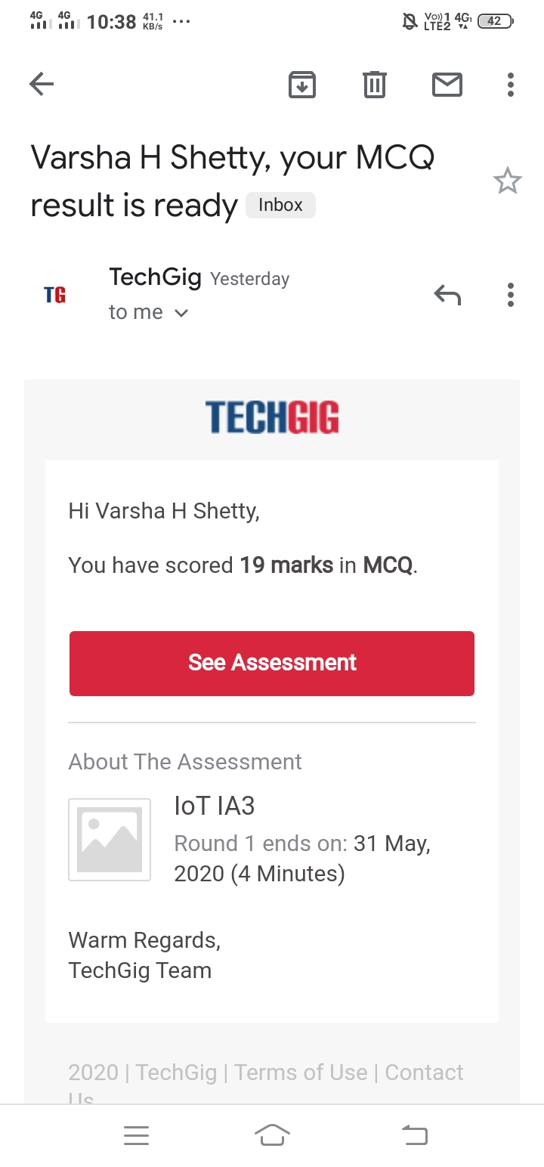

Certification Course Details:

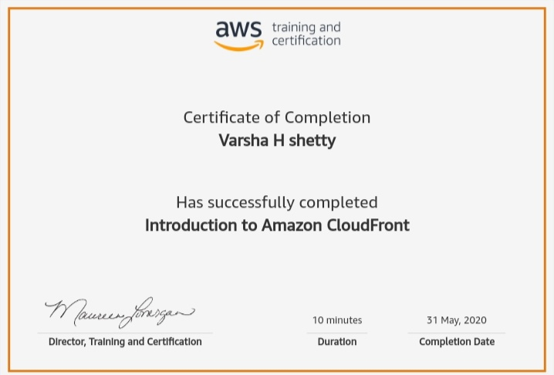

Coding Challenges Details:

#includestdio.h

voidswap(int*xp,int*yp)

{

inttemp=*xp;

*xp=*yp;

*yp=temp;

}

intbubbleSort(intarr[],intn)

{

inti,j,count=0;

intswapped;

for(i=0;i<n-1;i++)

{

swapped=0;

for(j=0;j<n-i-1;j++)

{

if(arr[j]>arr[j+1])

{

swap(&arr[j],&arr[j+1]);

swapped=1;

count++;

}

}

if(swapped==0)

break;

}

returncount;

}

voidprintArray(intarr[],intsize)

{

inti;

for(i=0;i<size;i++)

printf("%d",arr[i])

printf("\n");

}

intmain()

{

intarr[50],num;

printf("enterthenumberofelements");

scanf("%d",&num);

printf("entertheelements");

for(inti=0;i=n;i++)

}